M3 H1-Supply chain –Order system using Dataverse CRUD Operations
Step 1: Create Tables in Dataverse using Copilot
Open Power Apps go to make.powerspps.com
- Create Solution – Click Solution menu New Solution
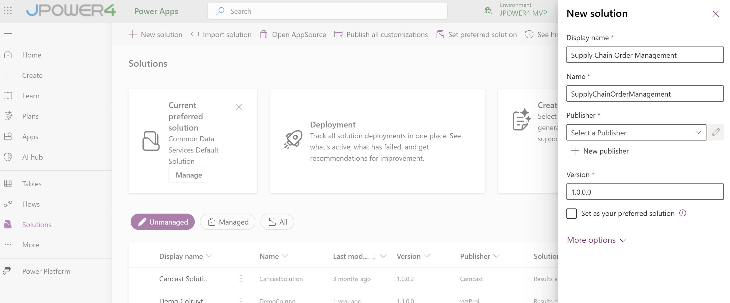
- Add Solution Name
- Create publisher
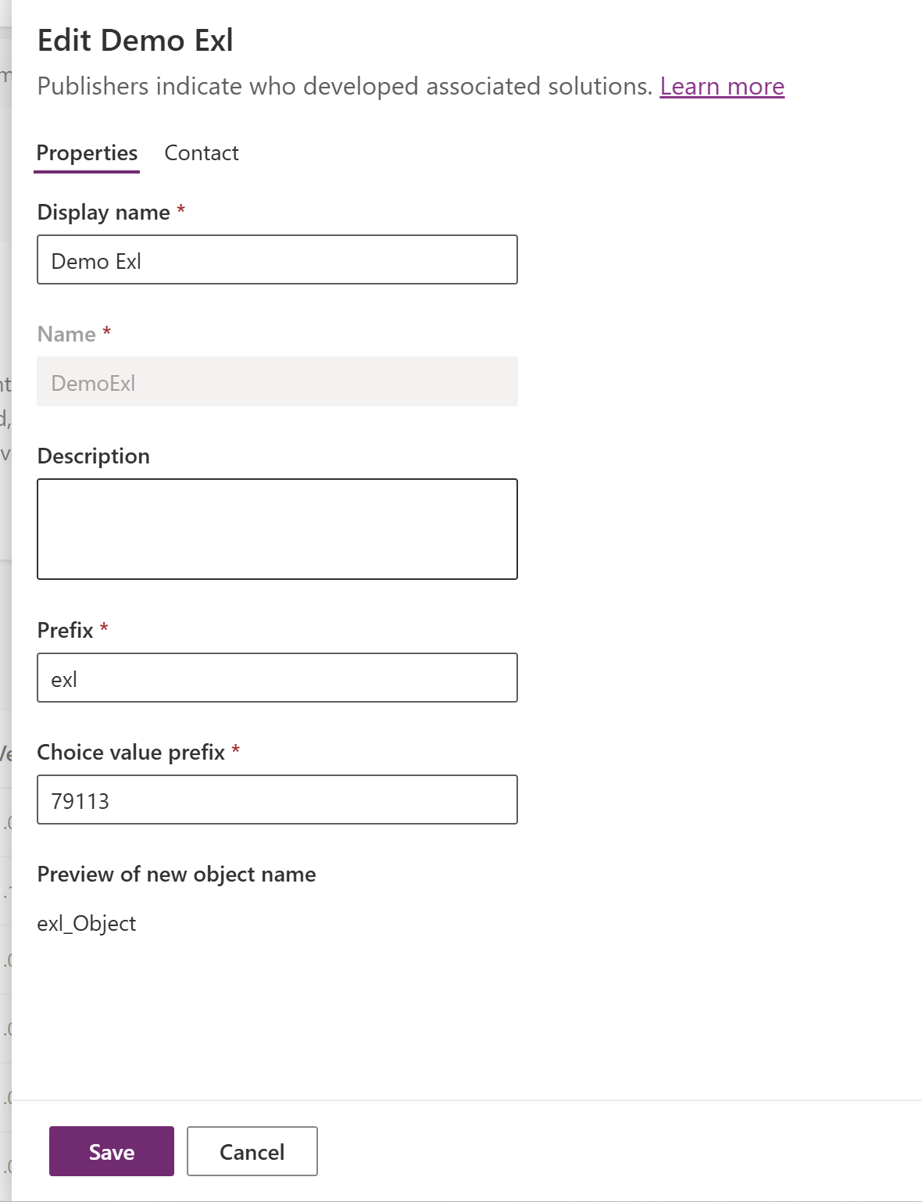
- select the created published
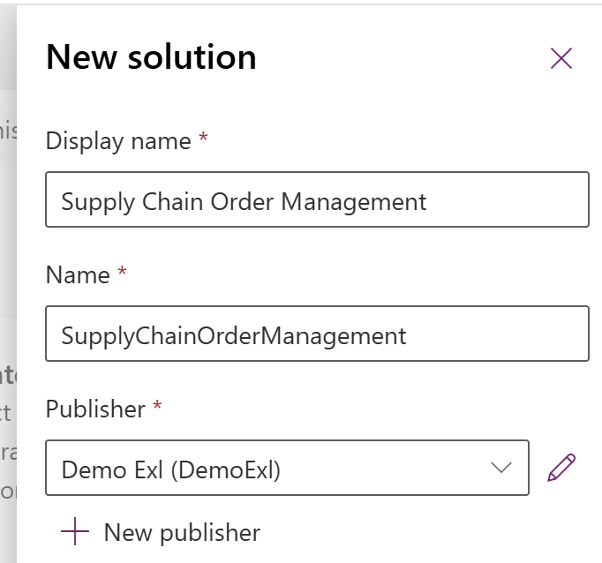
- Create it
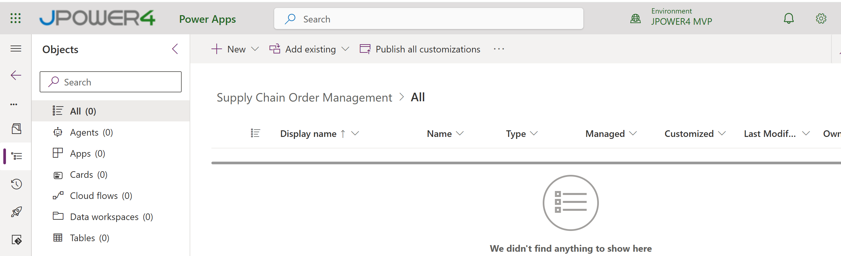
- Click New Table Tables
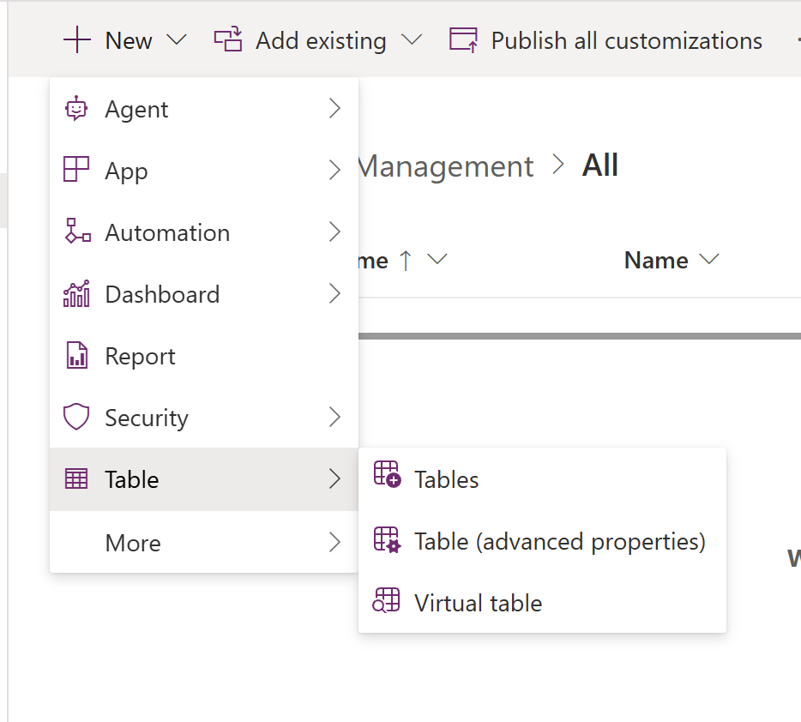
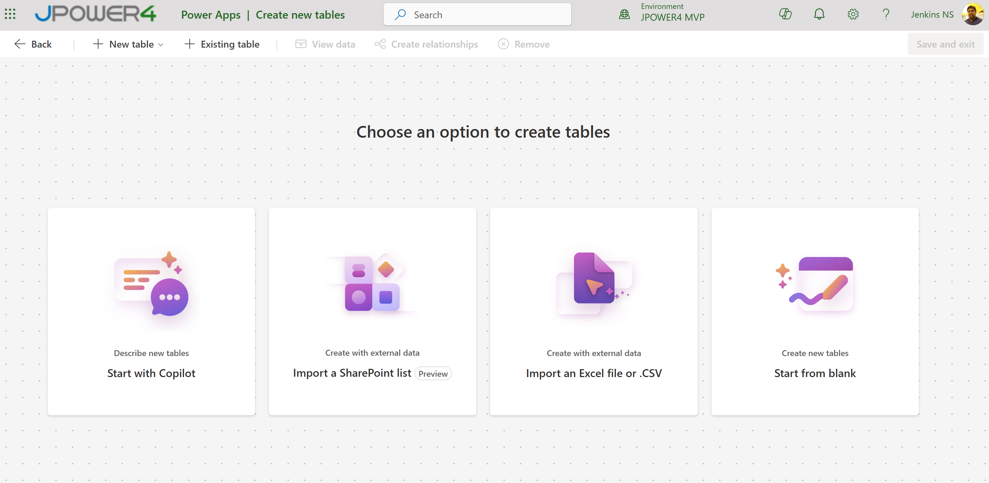
- Start with copilot
- Prompt to create 2 tables
Please create two Data verse tables for an Internal Order system where employees can order items like Laptops, Keyboards, headsets, Mouse from a company catalog
Table 1: Catalog Items - Item Name, Category (Choice: Office Supplies, IT Equipment, Access & Security, Stationery, Other), Description, Available (Yes/No)
Table 2: Internal Orders - Order ID, Item(Lookup to Catalog Items, required), Quantity, Order Date, Needed By (date), Delivery Location, Order Status (Choice: Submitted, Apporoved, In Progress, Ordered, Delivered, Denied), Notes
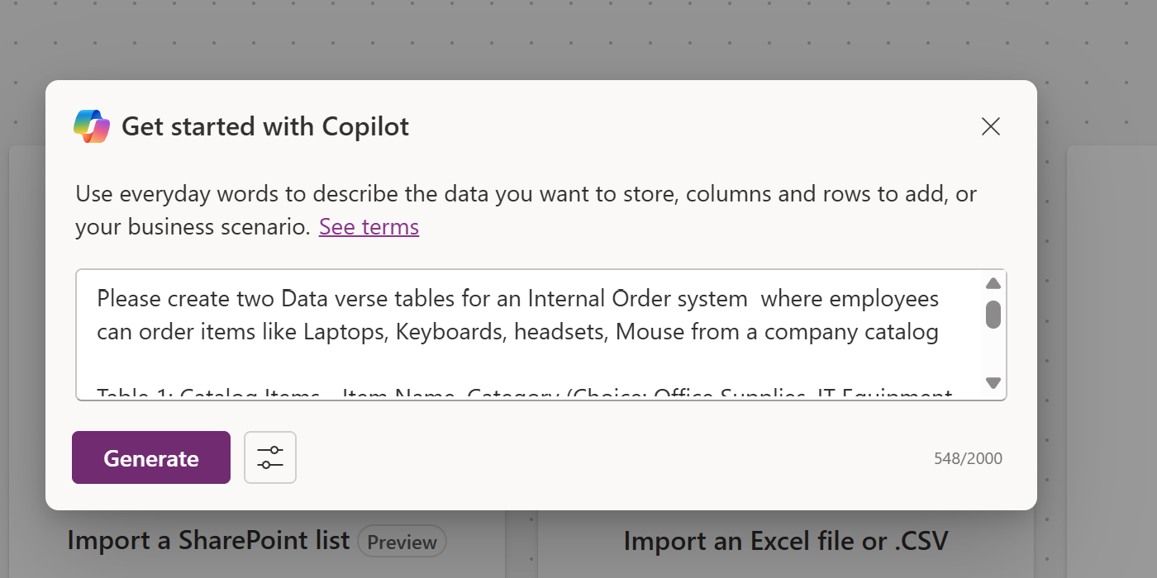

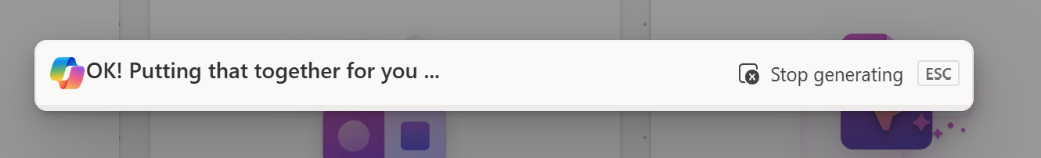
It created 2 tables with sample records
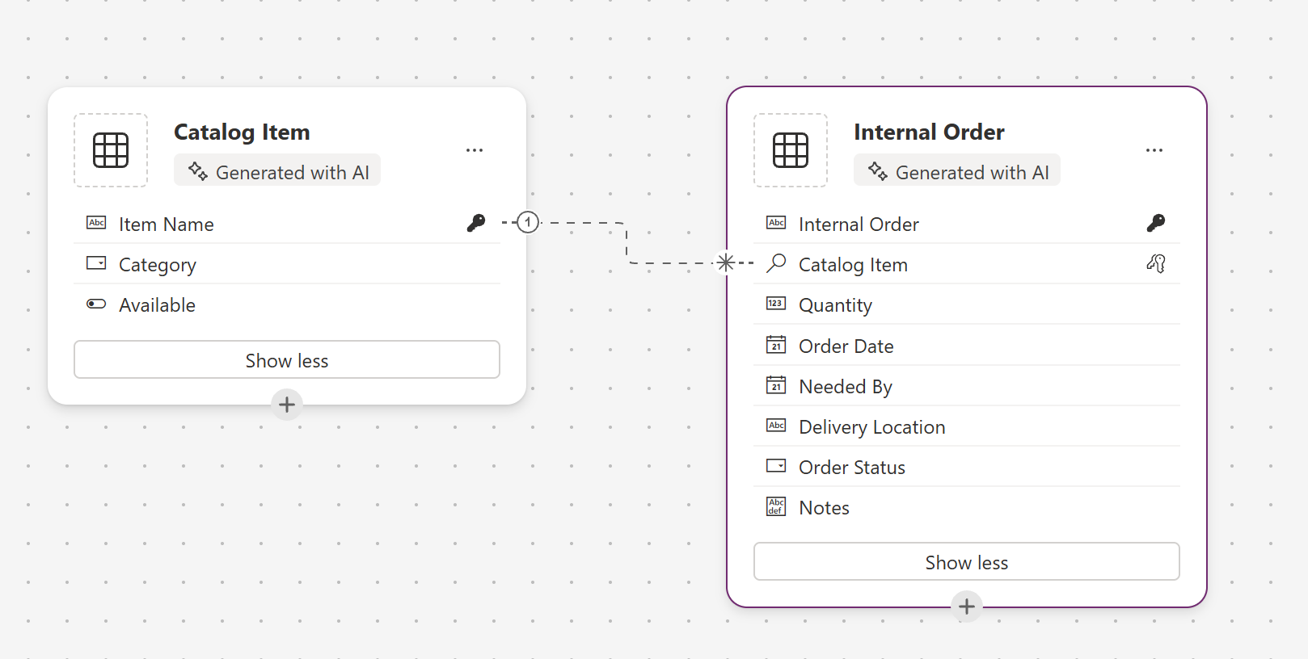
We can Add columns manually
Go to view data in Internal Order table click … view data
We create Order Id in Internal Order table
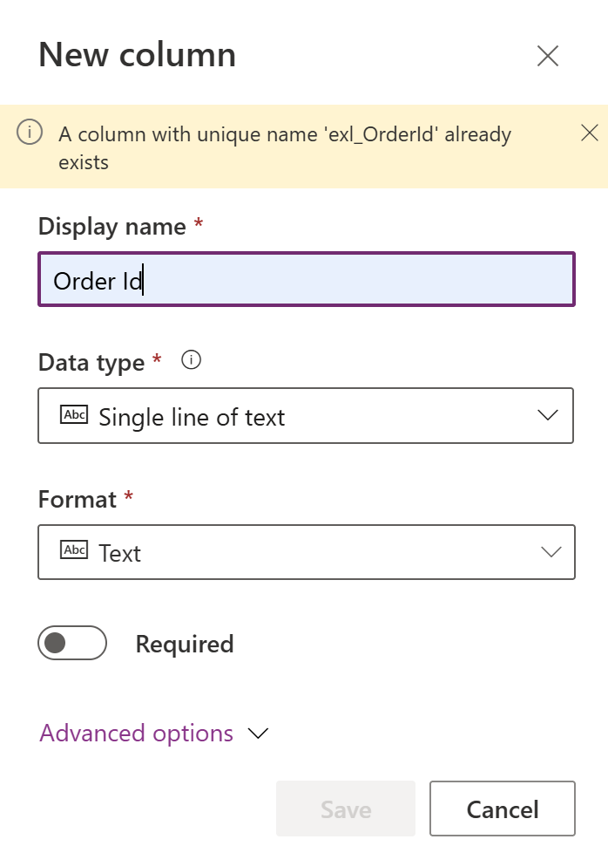
Also update the properties Order Id as primary key
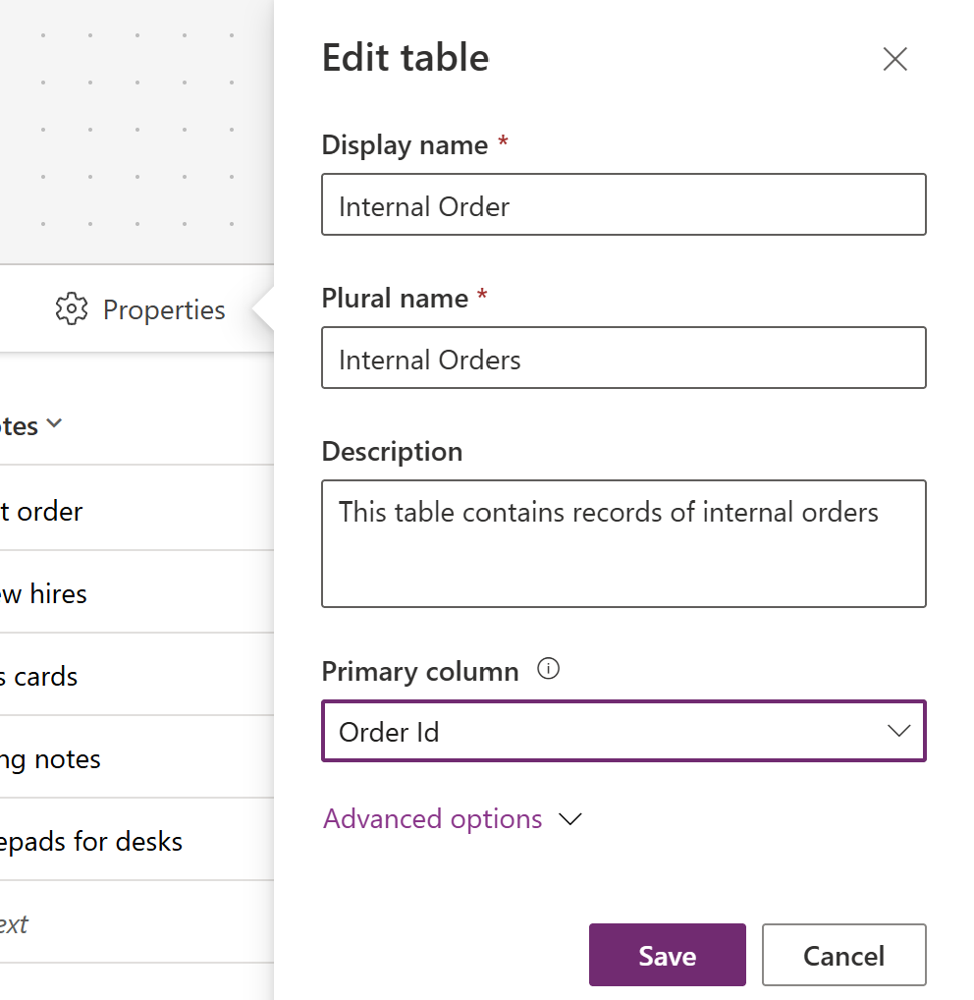
Save it

Then add a prompt regenerate data for both tables – add 25 records
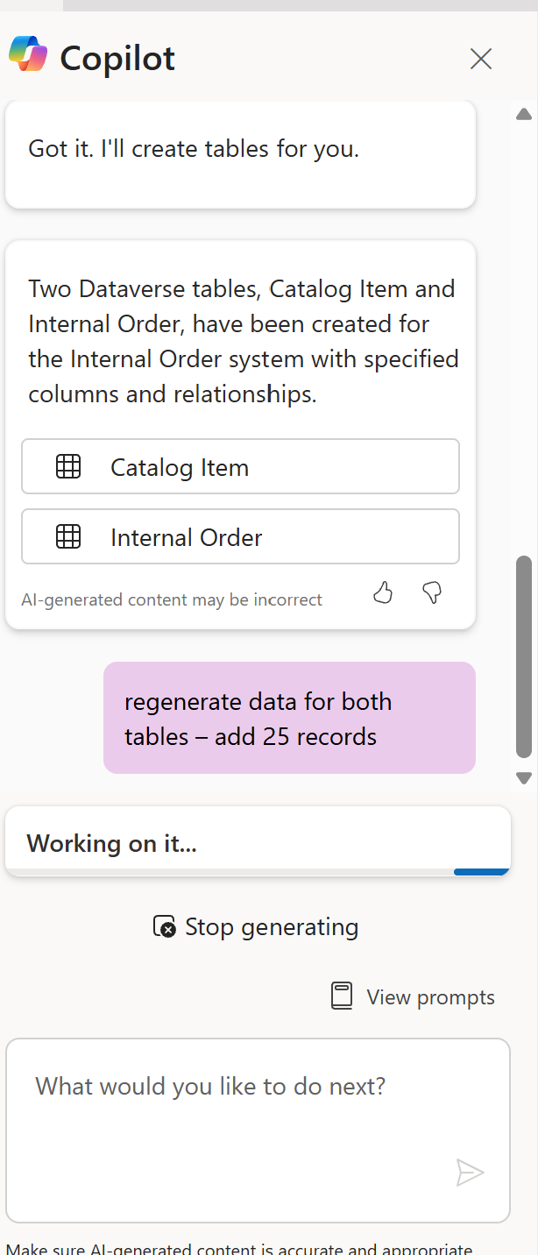
The output like below
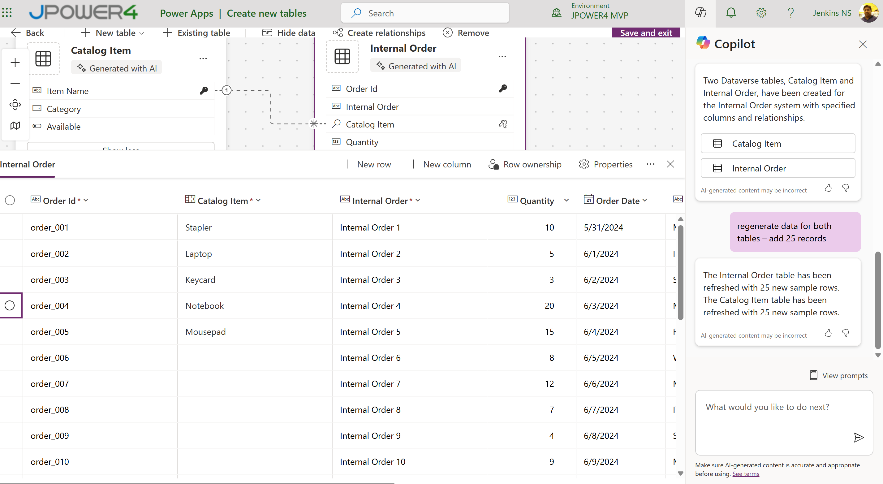
Save and exit
Two tables created under the solution

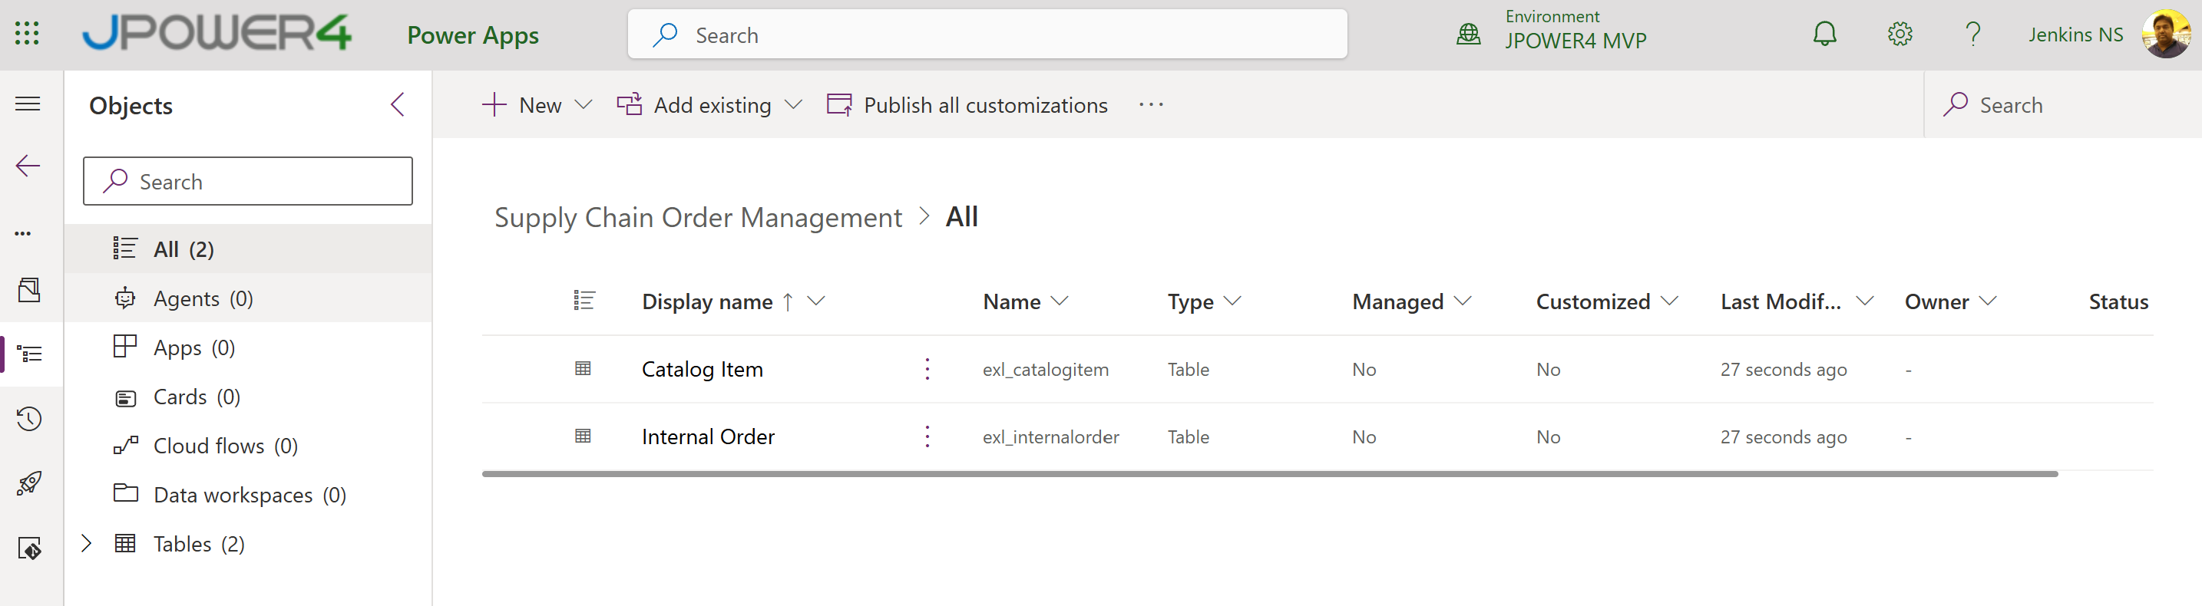
Step 2: Create the app using the degit template and deploy it to Power Apps.
Open Visual Studio
Terminal New Terminal move to Project folder
PS C:\Development\CodeApps>
Run following comment
npx degit github:microsoft/PowerAppsCodeApps/templates/vite OrderSupplySystem
cd OrderSupplySystem
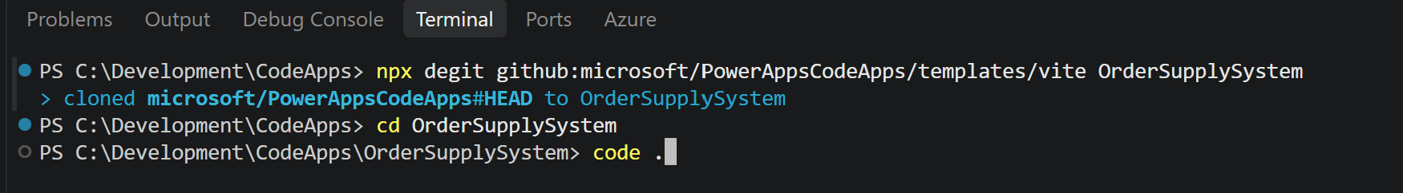
Install the Power Apps CLI and the project dependencies:
npm install --global @microsoft/power-apps-cli
npm install --global @microsoft/power-apps
npm install
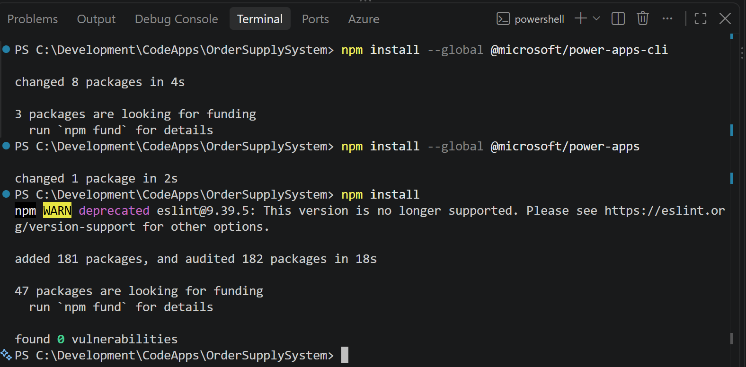
Initialize the app
pa app init
Enter Environment ID
Get the environment ID from your Power Apps your environment
Make.Powerapps.com Settings Session details
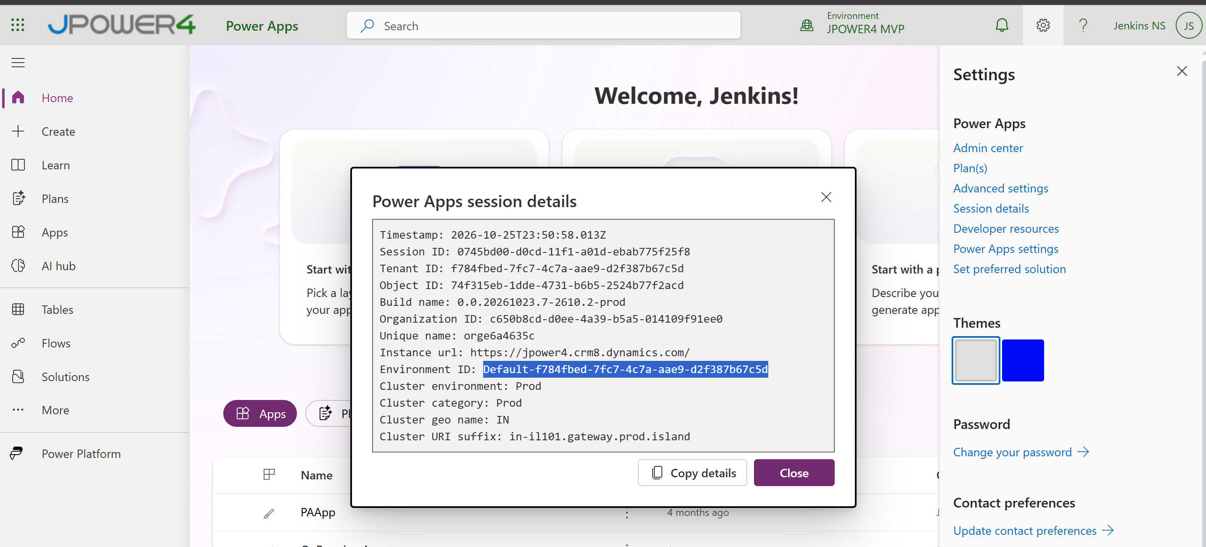
It opens a browser and login
Enter Display Name

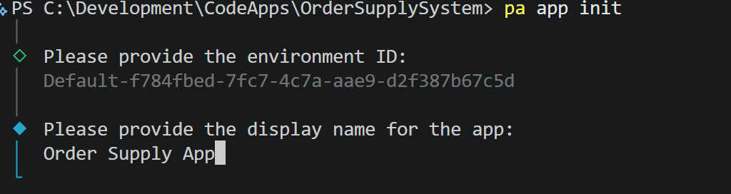
It creates power.config.json file to manage the App details
Run the App locally pa app run
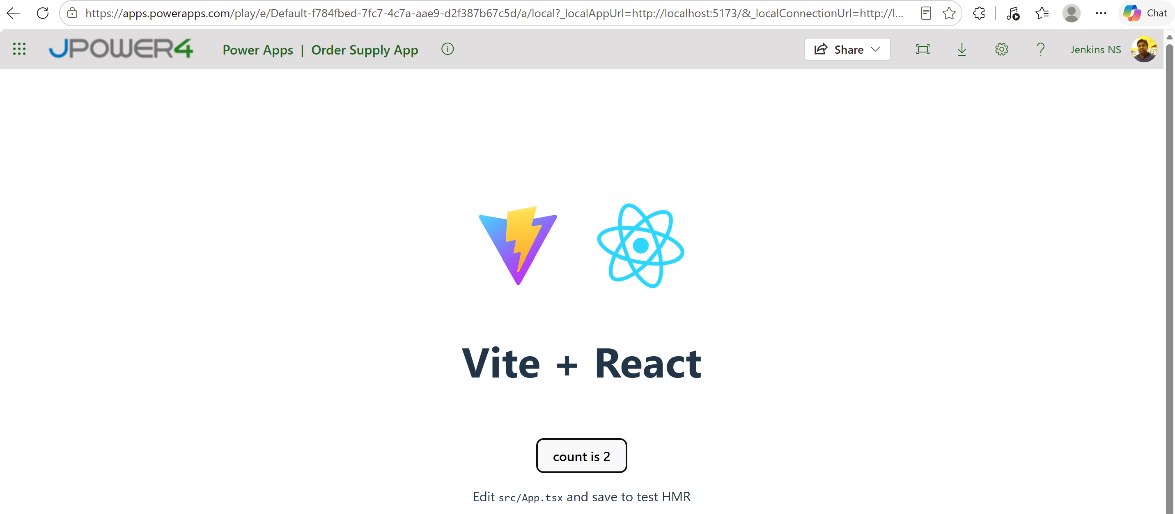
Build and deploy it in Power Apps
npm run build
- It create a ./dist folder with deployment files
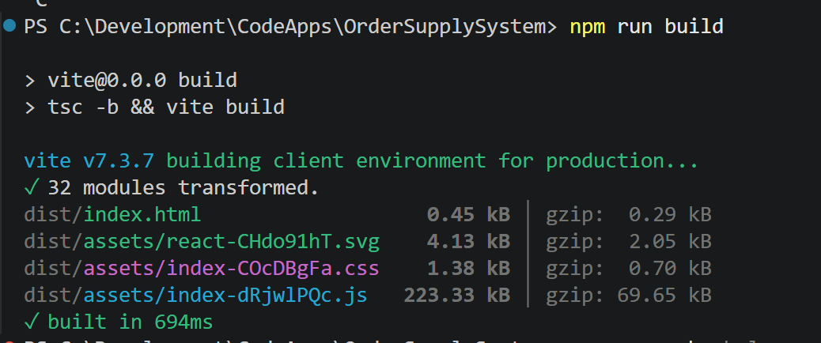
Push the app to Solution
Go to Solution and get the id copy from Solution url
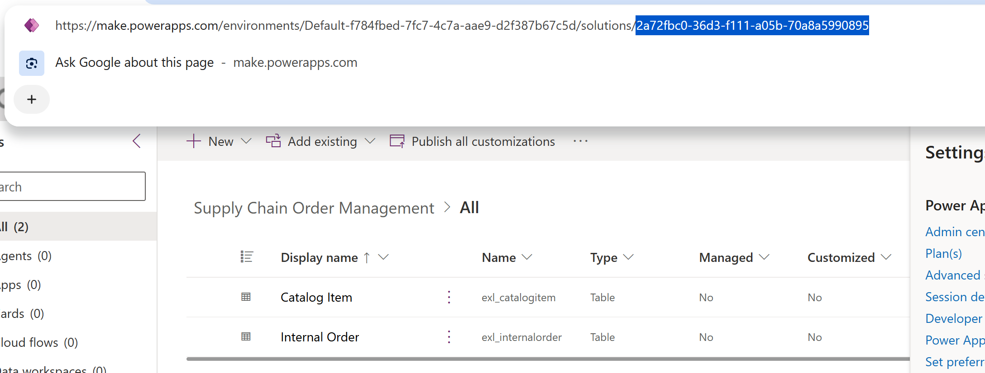
Run the push command with solution id
pa app push --solution-id 2a72fbc0-36d3-f111-a05b-70a8a5990895
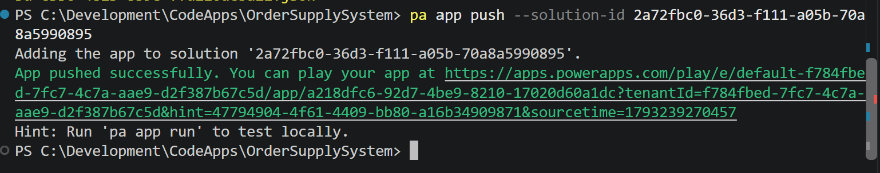
It deployed it in the solution
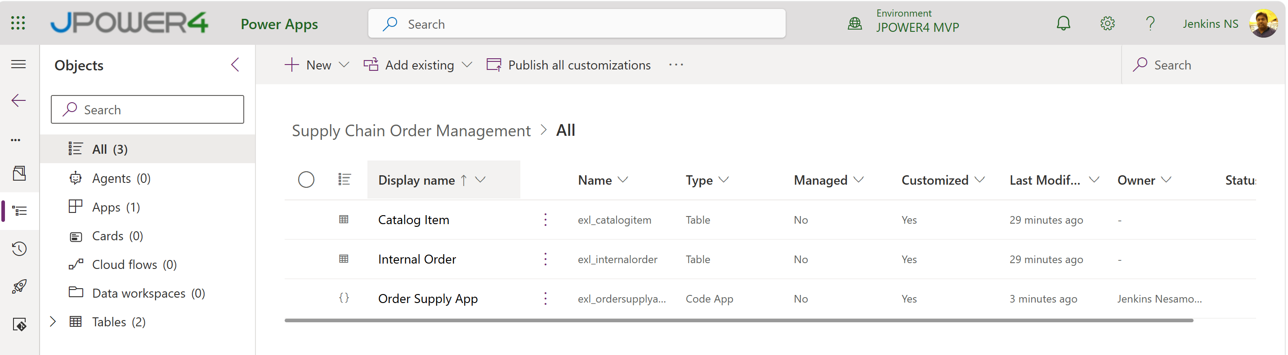
Run from PowerApps - Order Supply App - Power Apps
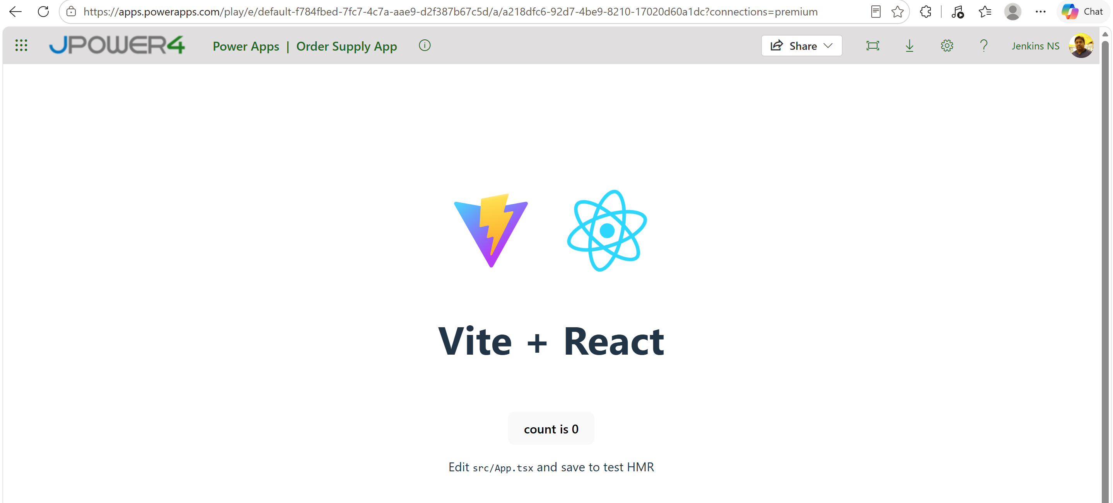
Step 3: Add Dataverse tables to the code
Run pa app add data-source
Enter Connector ID : Dataverse
Table name : logical name : exl_catalogitem
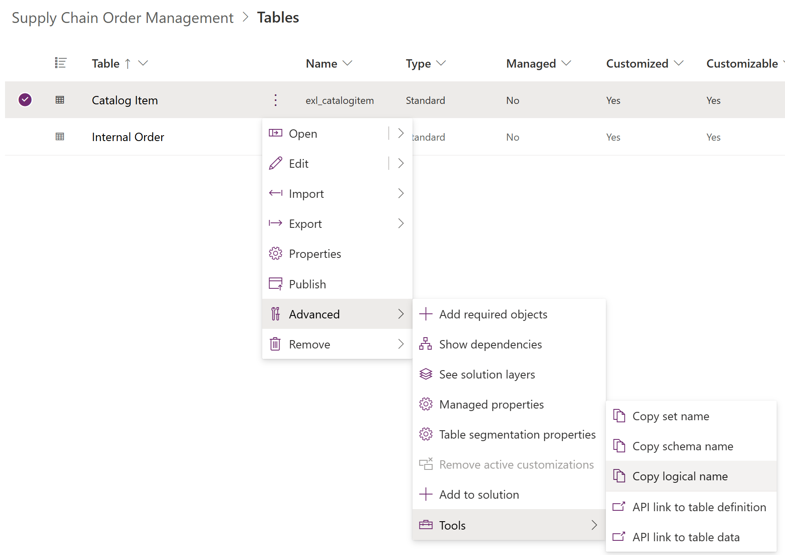
Organization URL: https://jpower4.crm8.dynamics.com/

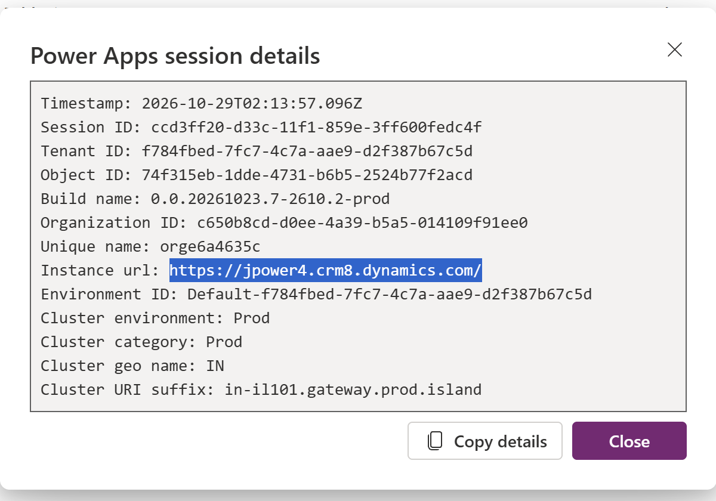
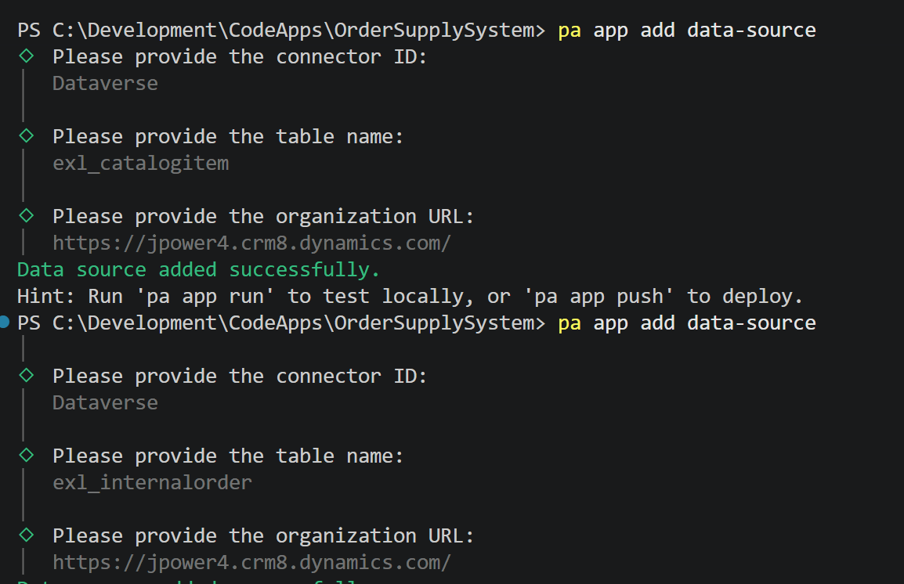
It generated the code
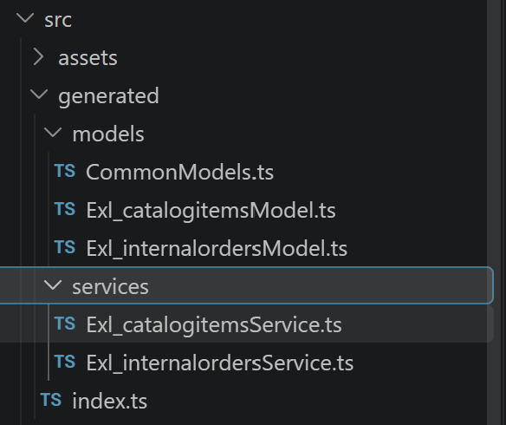

Step 4: Update App code to create, manage, and track orders efficiently.
Go to visual studio code and update the code using prompt
Goto APP.tsx
Enter the prompt in the chat window
Update the app using the connected dataverse data sources
App requirements
1.Layout
-sidebar with two sections: 'Catalog' and 'My Orders'
-Top header: 'Supply Hub' + Current user's display name
-Modern Professional design, fully responsive
2.Catalog Page (default landing)
-fetch all catalog Items
-responsive card grid
-Filter bar: search by Item Name + filter by category
'Order' button on each card (disabled when Available = No)-> opens order model
3. Order model
-pre-files the selected Catalog item(read-only display of Item Name)
-Editable fields: Quantity (default 1); Needed by, Delivery location, Notes
-On submit create a new order:
-Item lookup --> Selected Catalog Item
-Ordered By --> current user (from user table)
-Order Date --> today
-Order Status --> "Submitted"
-Success toast + close model
4.My Orders Page
-Fetch Orders Page
-Fetch Orders where Ordered by = current user
-Table columns: Order Id, Item, Quantity, Order Date, Needed By, Status, Assigned To
-Sort by Order Date descending
-Status badge colors: Submitted = gray, Approved=blue, In Progress=yellow, Ordered=purple, Delivered=green, Denied=red
It generates the code and updates it
Buid it
Npm run build
Then push to Power Apps
pa app push --solution-id 2a72fbc0-36d3-f111-a05b-70a8a5990895
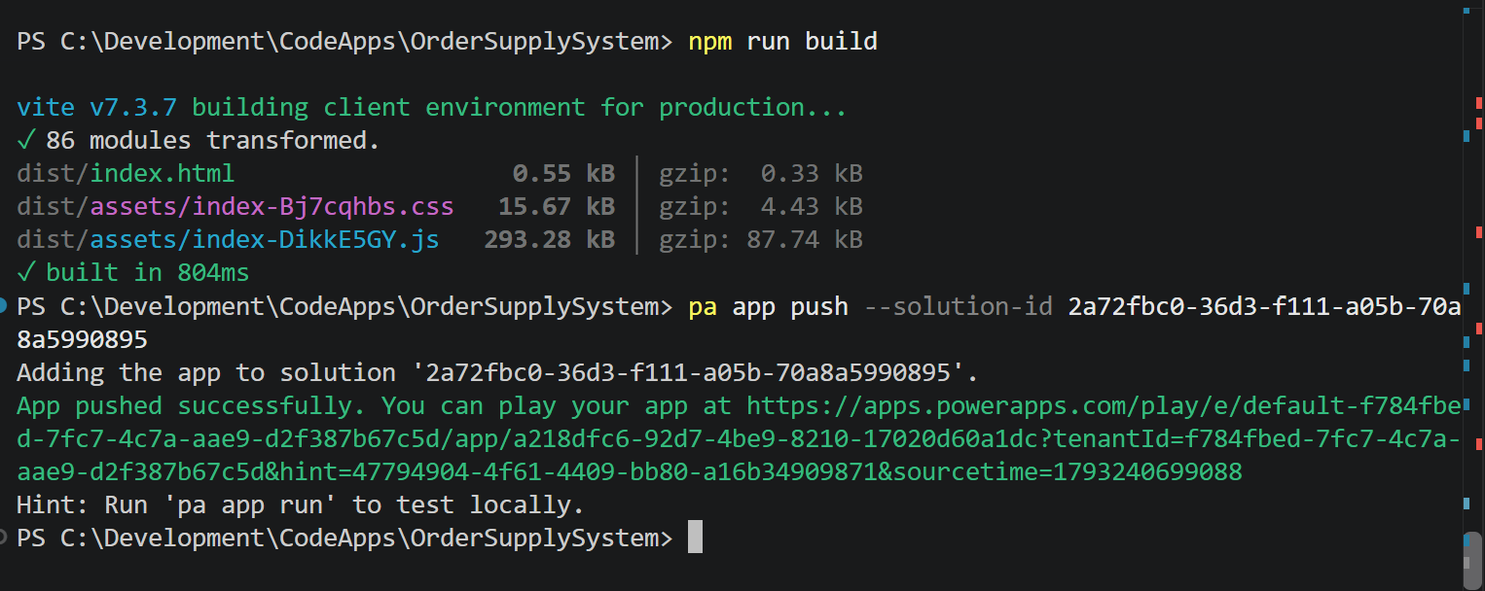
The output looks like below
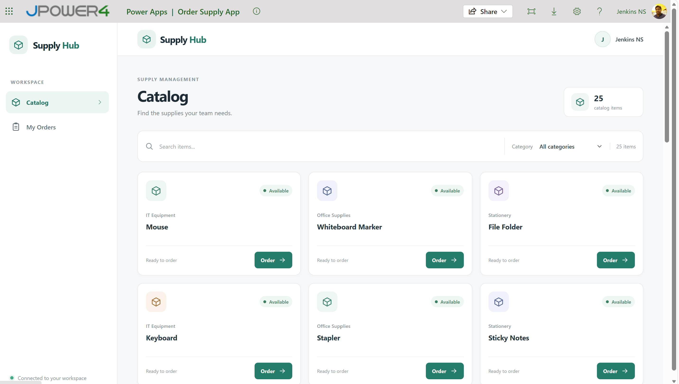
Step 5: Implement role-based security and update the code to support appropriate user roles and permissions.
Add Security roles
- Order Admin
- Order User
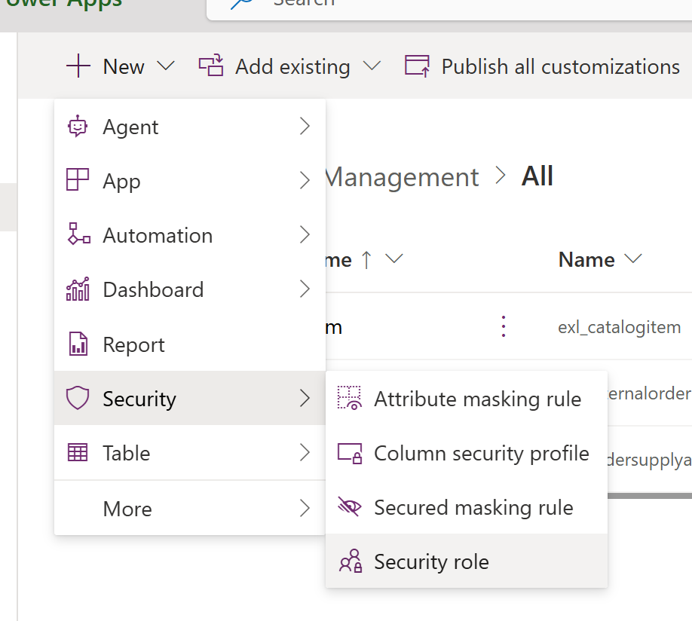
Add Security role
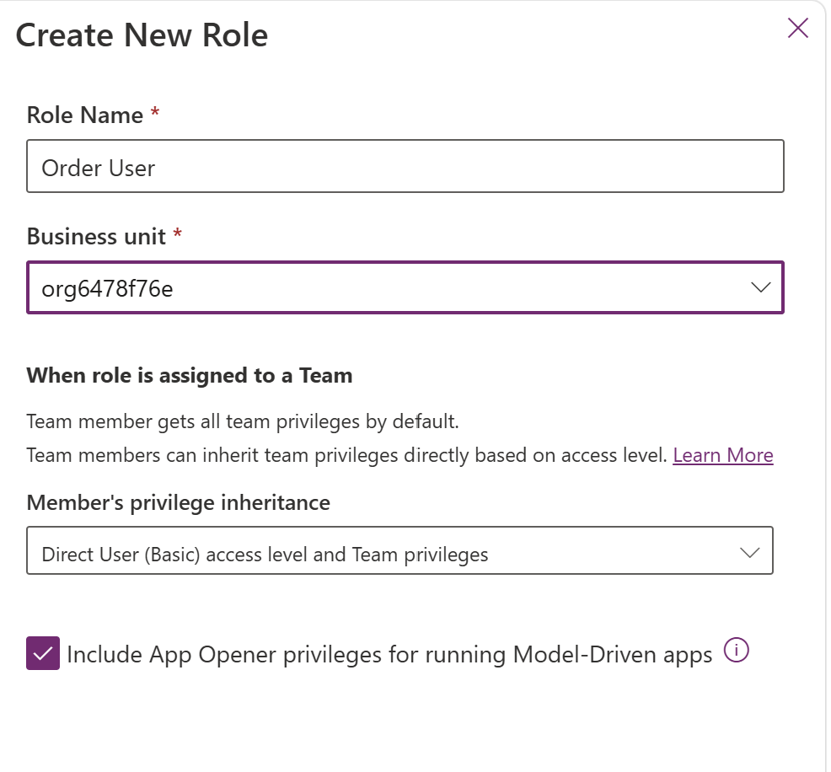
Grant full access Permission order Admin and Grant user permission for Order user
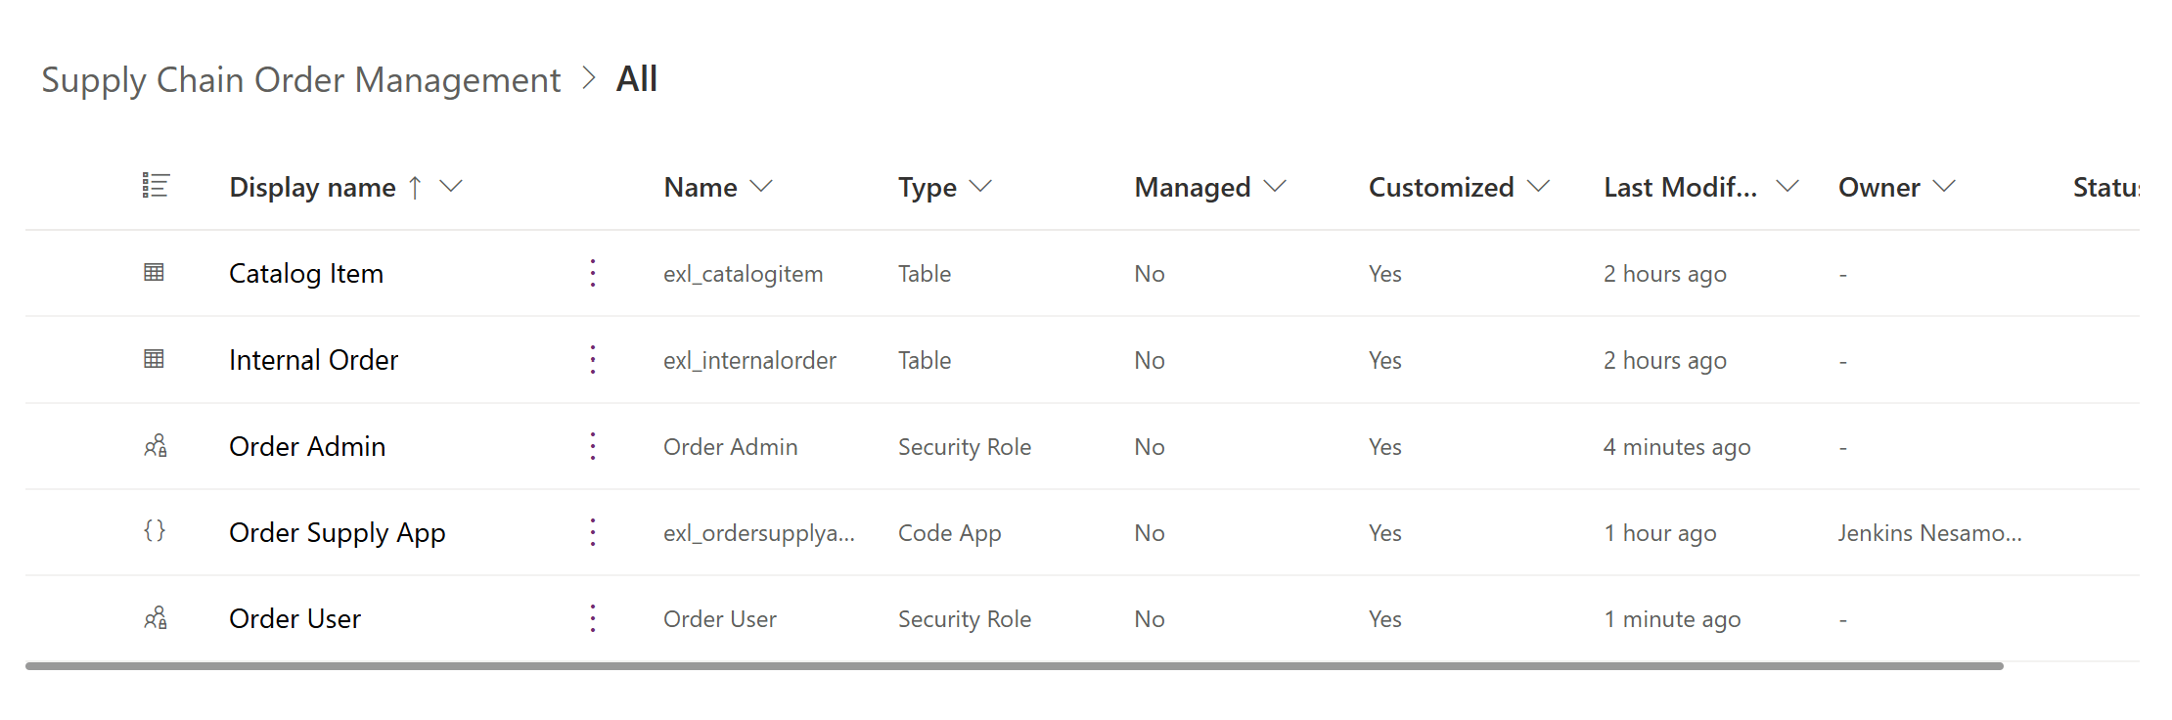
Add permission to the code, same as data-source adding
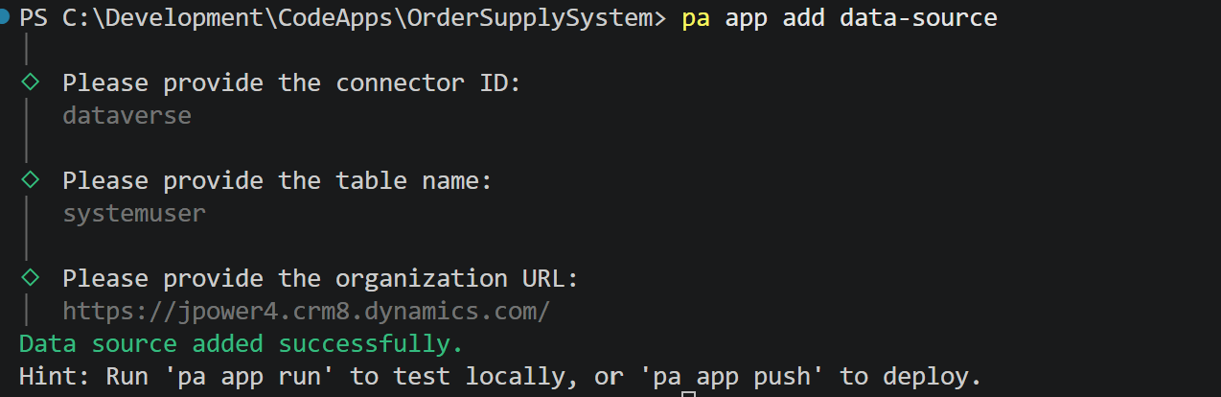
Table name: systemuser
Then execute below prompt in chat to update role based view
Role-based Access control
Check the current user's security roles via the user table's security roles association. Two roles are relevant:
-"Order Admin" - full access
-"Order User" - restricted to their own orders
Branch the UI based on role:
If user has "Order Admin" role:
-Sidebar shows: catalog, My Orders, All Orders, Reports
-"All Orders" Page: table of every Order across all users
-Same columns as My Orders + "Ordered by" Column
-Filters: by Status, by Assigned To, by Date range
-Admin can edit Order Status and Assigned To inline (or via row action)
-"Reports" page: simple dashboard with:
-Total orders by Status (bar chart)
-Orders by Category (pie chart)
-Orders over time (line chart, last 30 days)
-Top 5 most-ordered items
-Admin can also create/edit/deactivate Catalog Items from the Catalog page (show "Manage" toggle)
If user has "Order User" role (or only Order user);
-Sidebar shows: Catalog, My Orders only
-Catalog is read-only browsing + Ordering
-My Orders shows only orders where Ordered By = current user
-No access to All Orders or Reports routes (redirect to Catlog if attempted)
If user has Neither role:
-Show a friendly "Access Denied - Please contact your administrator" screen

After completed Build and push to power platform
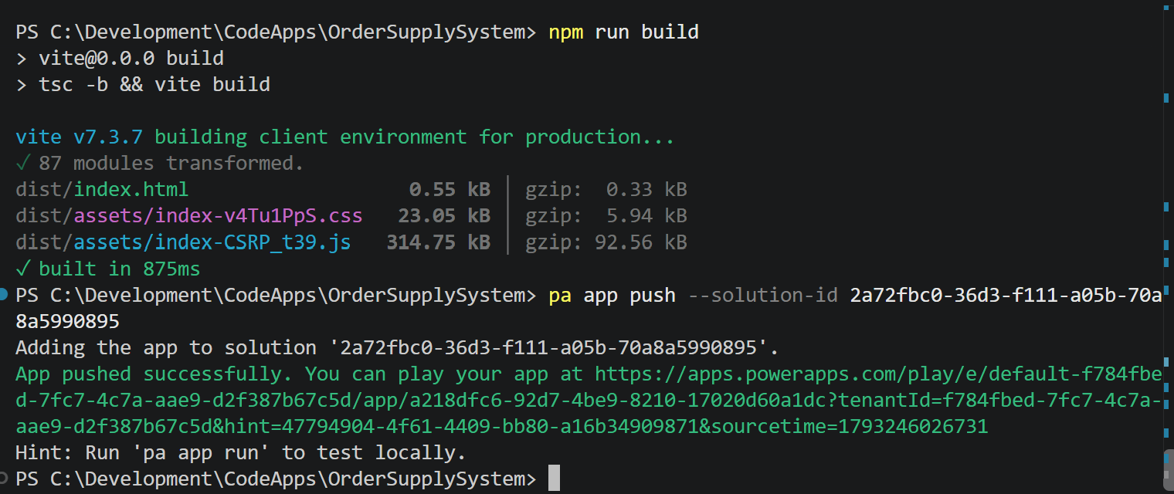

Testing
First no permission for any one

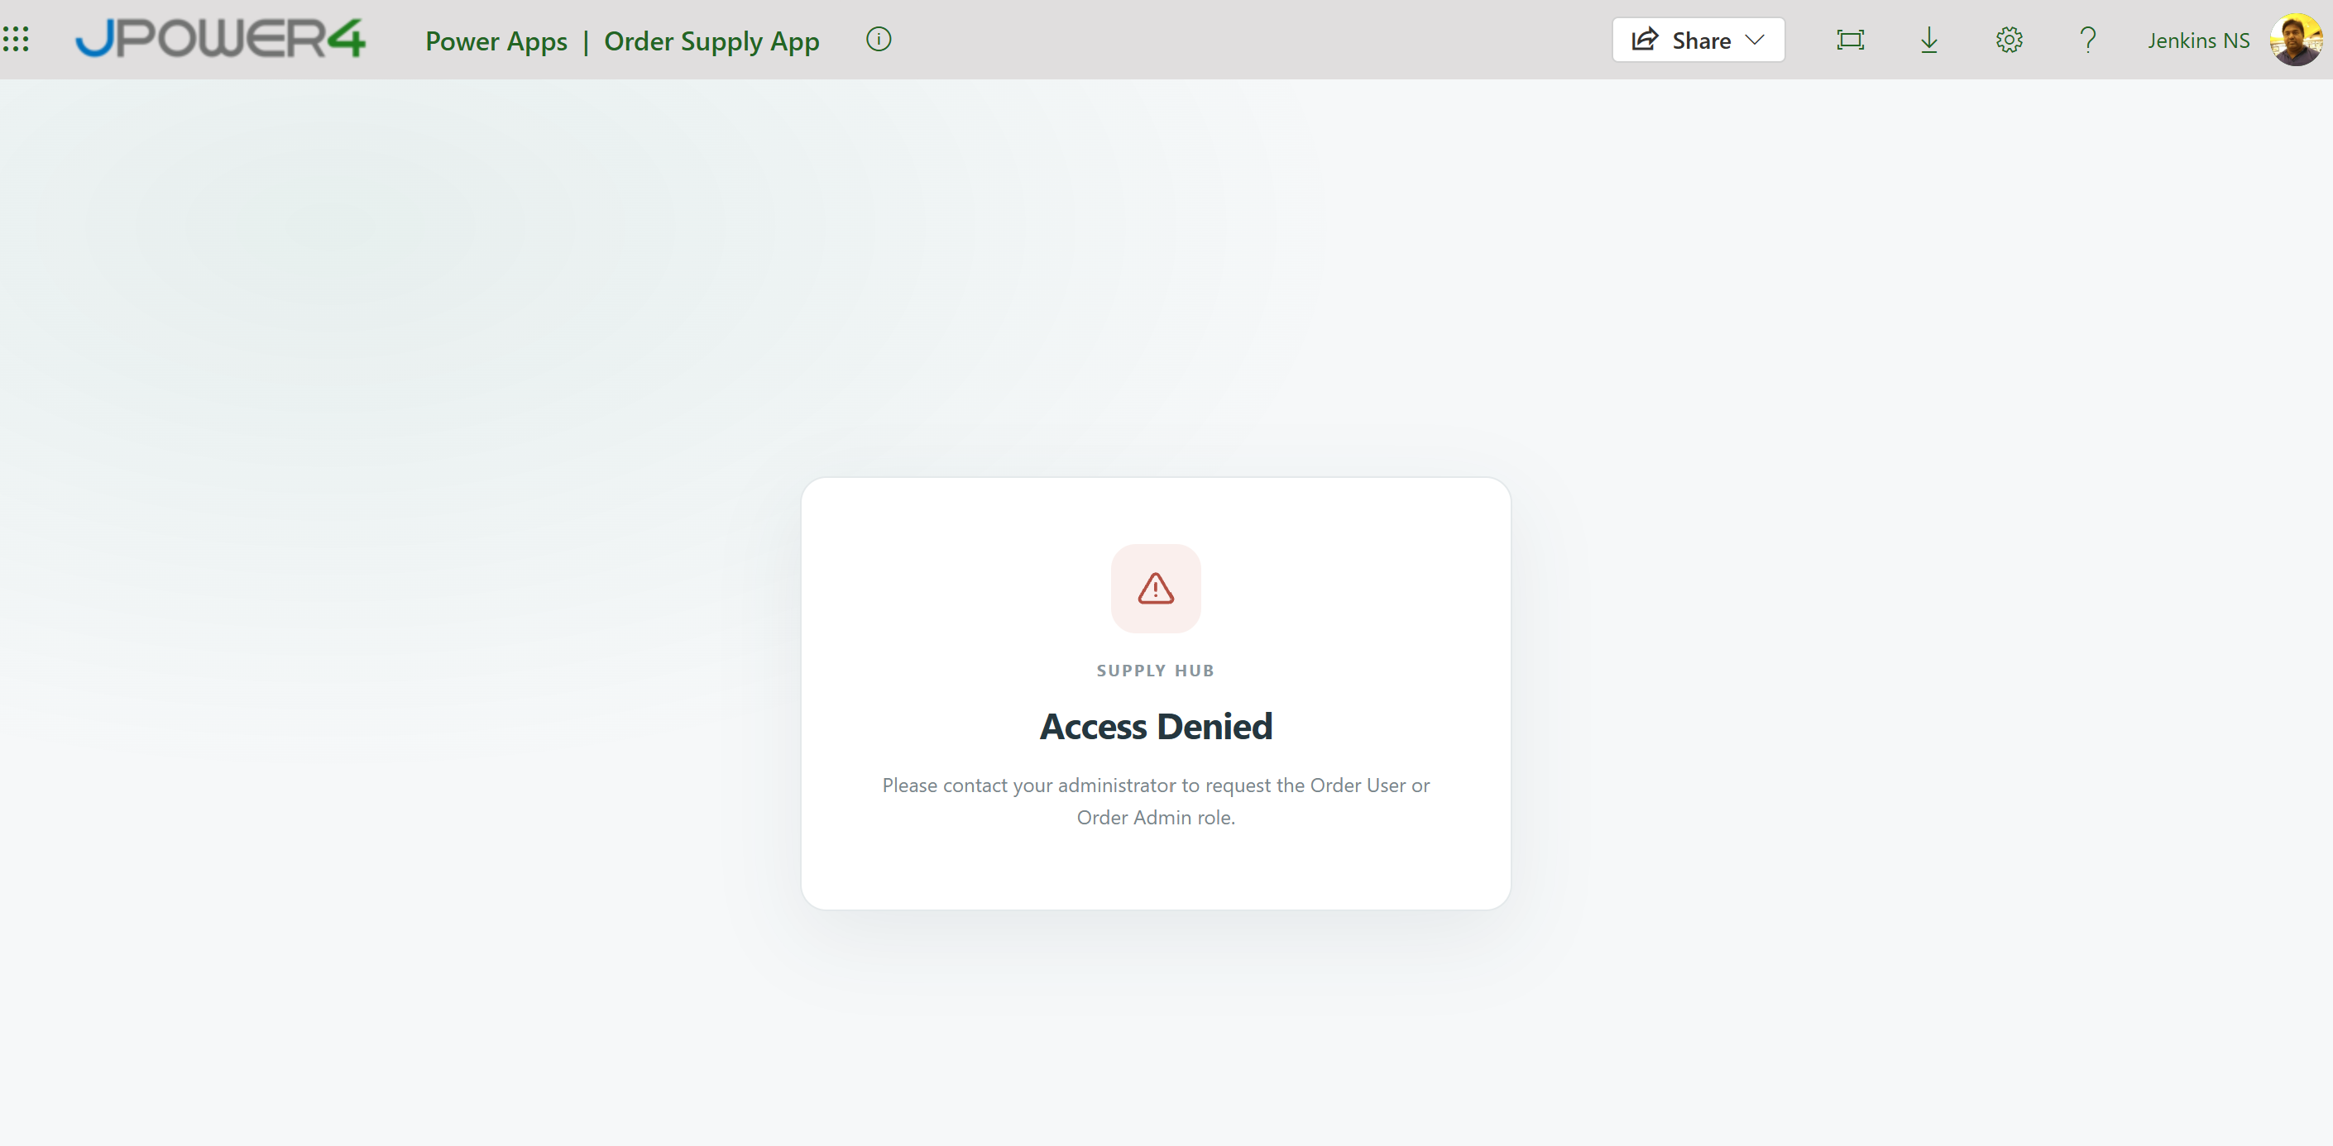

Grant Order Admin role permission
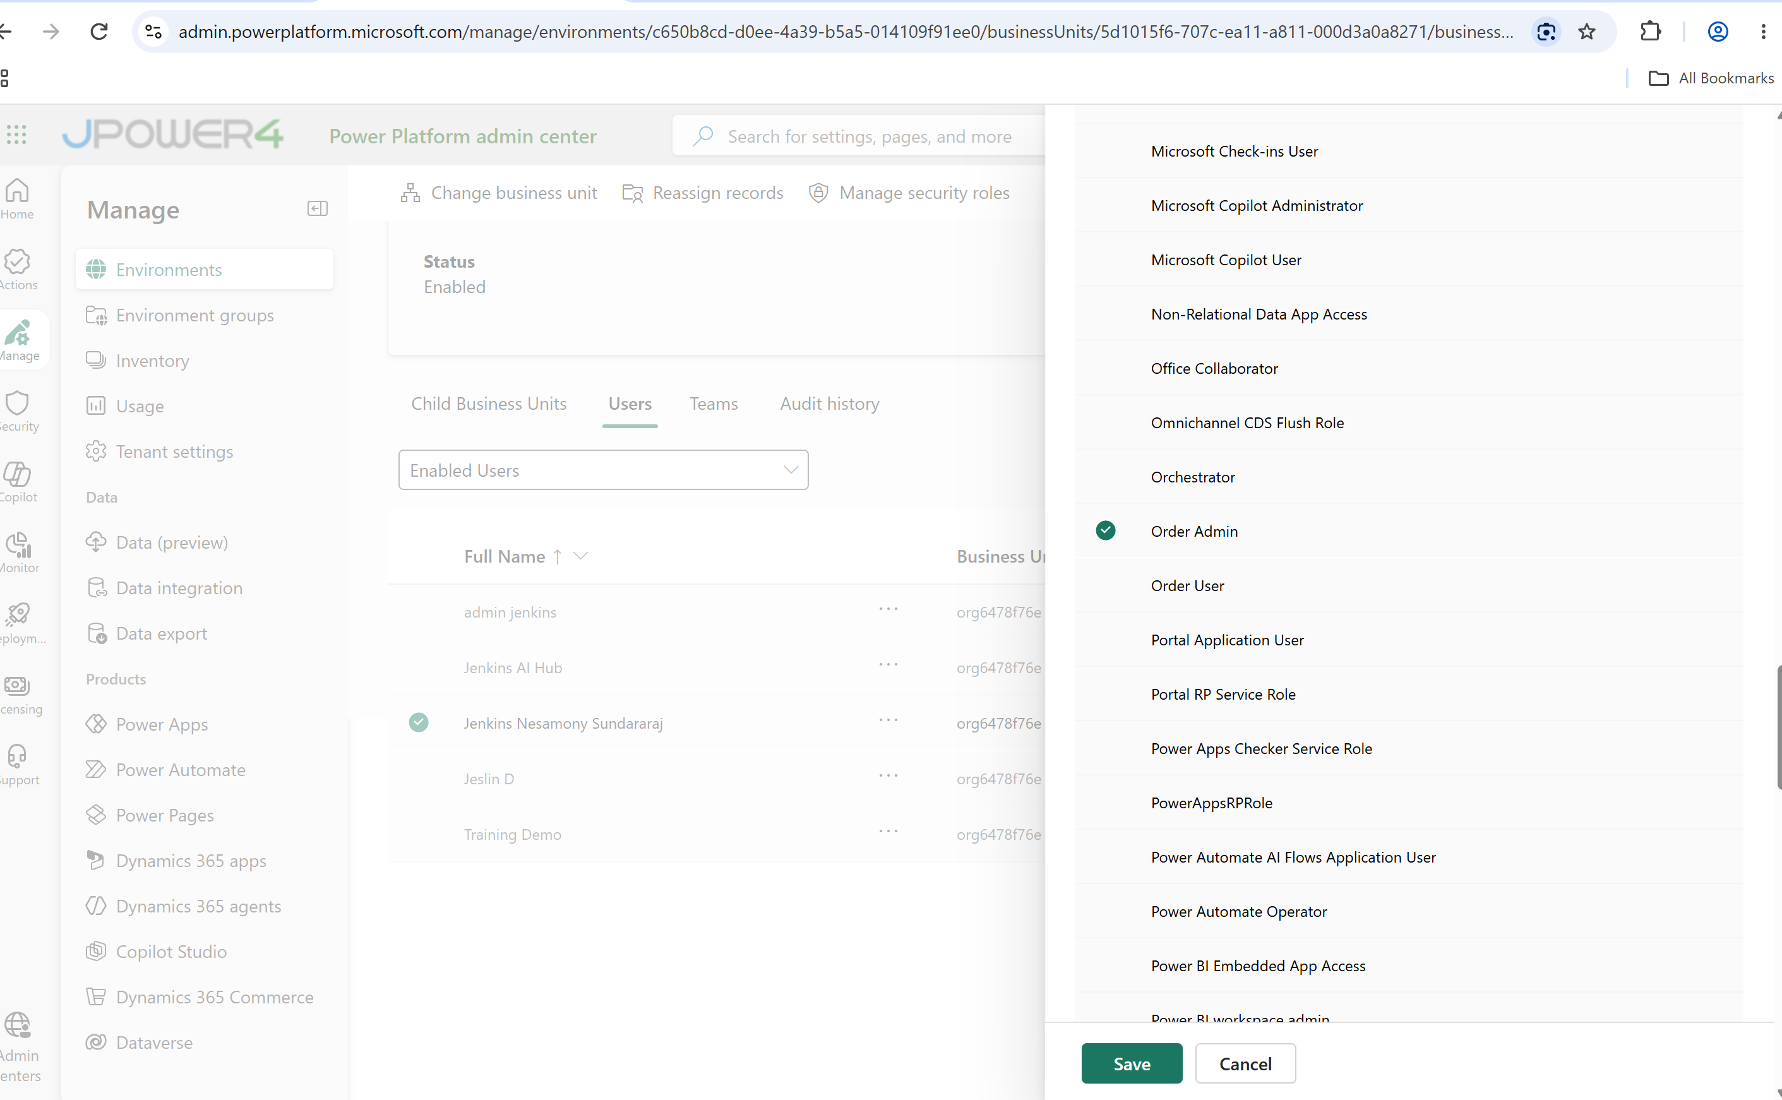
Output
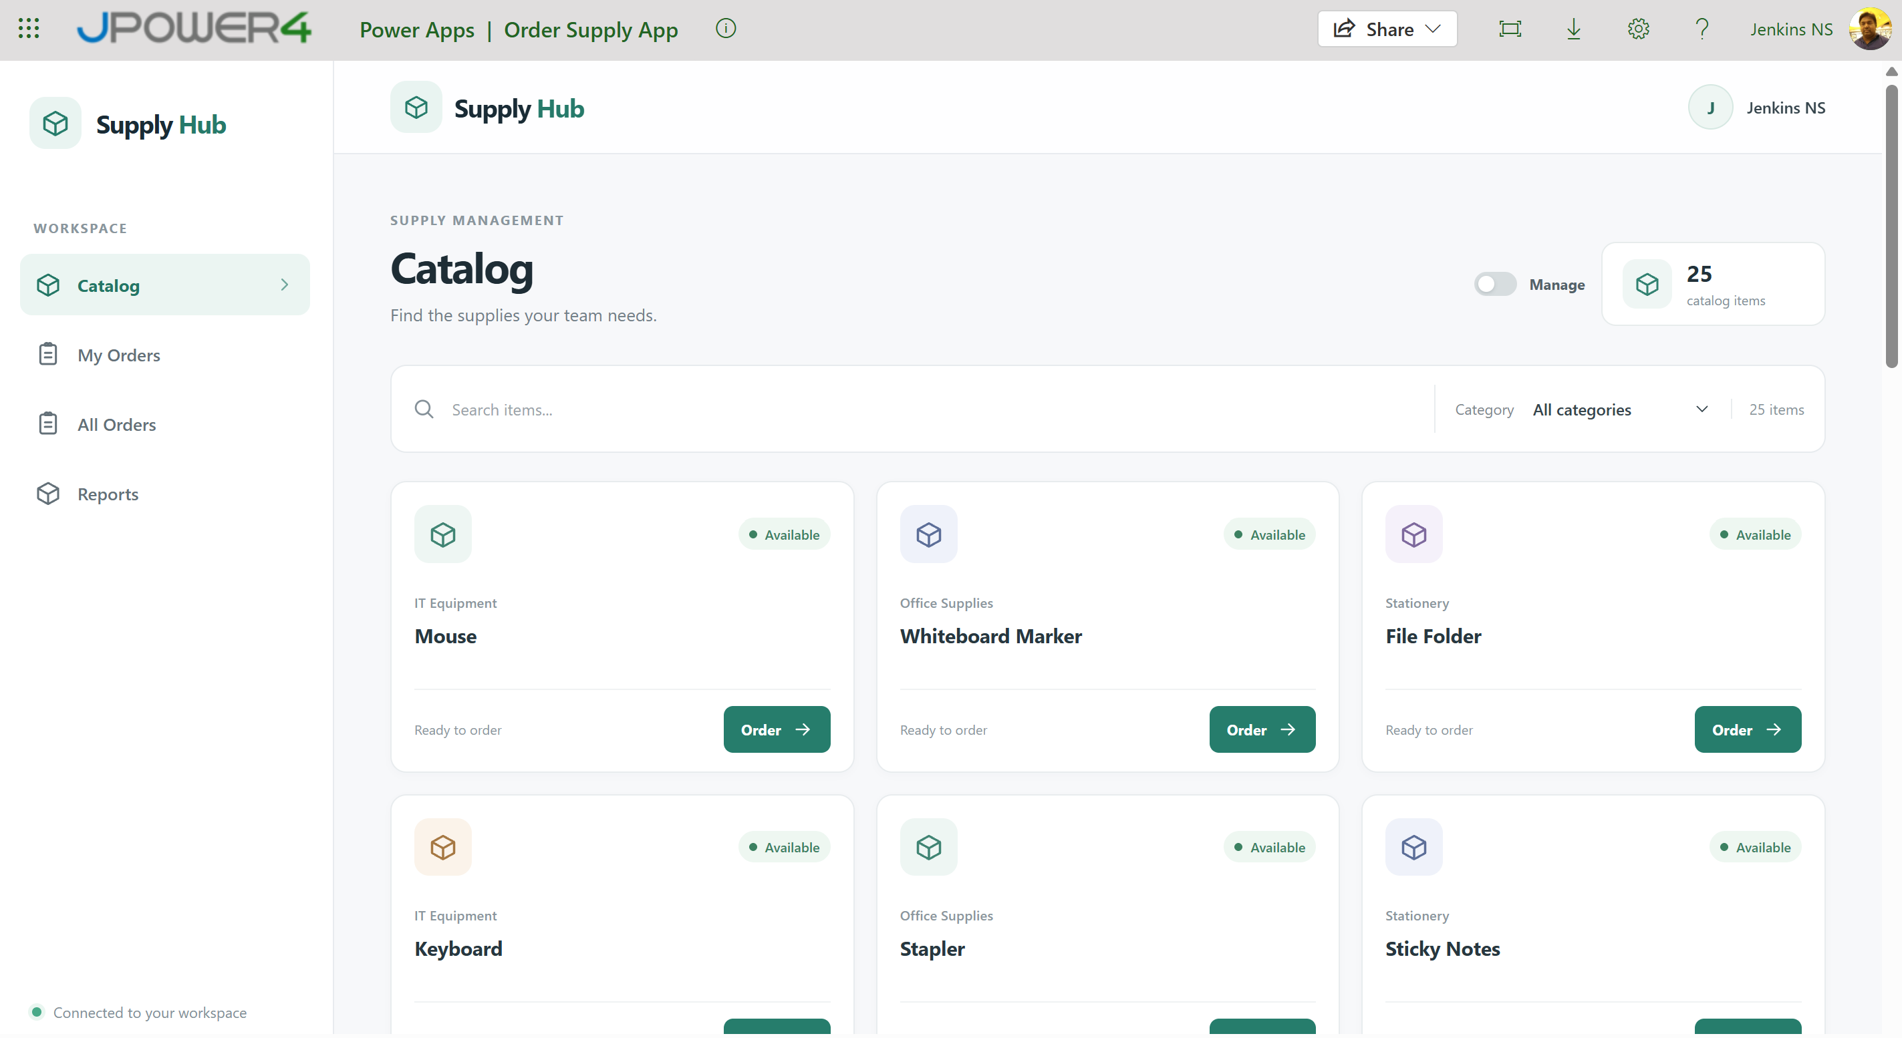

Granted Order User role
